Plain language summary
When early life changes the brain, behaviour does not always follow
Animals need healthy brain cells to detect and respond to important things in their environment, such as prey. Producing the energy needed to keep cells working involves natural chemical reactions that also generate molecules capable of damaging cells. Normally, cells can avoid or even repair this damage, but the balance between producing energy and avoiding cellular damage can be affected by the conditions animals grow up in.
Early stages of development may be particularly relevant for these effects. In lizards, temperature and stress hormones during the incubation period can have important effects on brain function and cellular processes that persist long after the incubation period. However, we do not know exactly how temperature and stress hormones can affect brain cell function when they act together. In addition, much less is known about how changes in brain cells caused by the early environment ultimately translate into changes in how animals detect and respond to prey.
We tested whether incubation temperature and exposure to a stress hormone during development had lasting effects on how lizards detect prey, and whether these effects were related to changes in energy production and cellular damage in different regions of the brain. We found that the incubation environment affected energy production and cellular damage in some brain regions, as well as prey-detection behaviour. However, changes in brain function and behaviour were surprisingly not closely linked. Our results show that the environment experienced early in life can have lasting effects on both the brain and behaviour of lizards, but that these effects do not necessarily occur together.
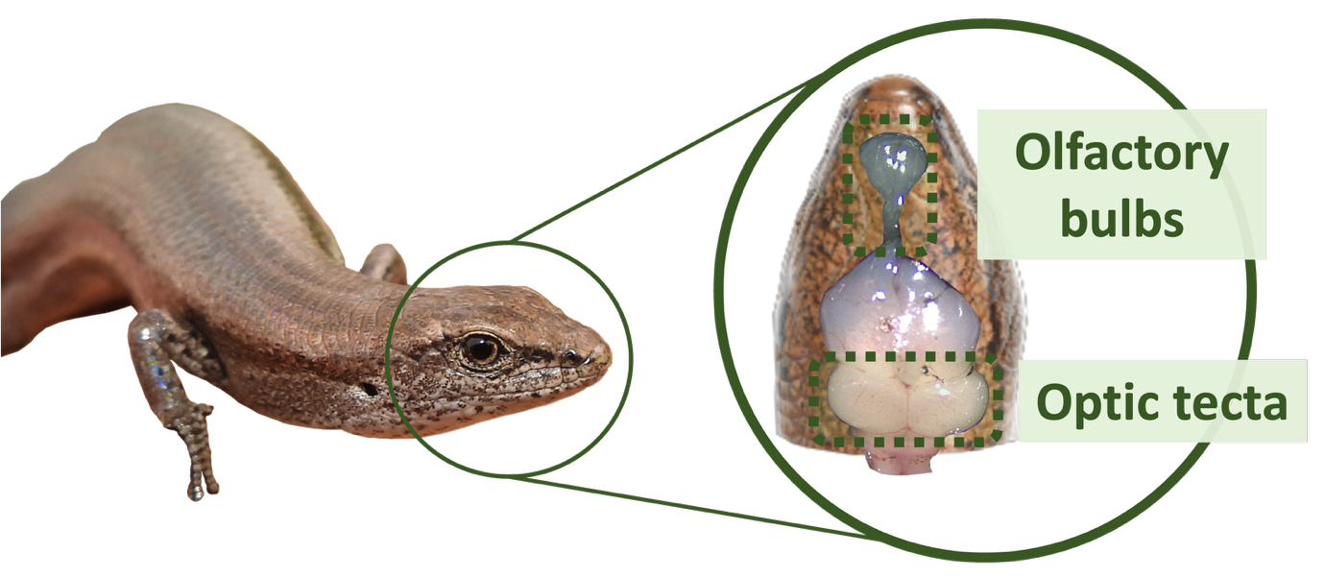
Picture credits: Pablo Recio

